Unit 1 How do you study for a test?
Teaching aims:
Knowledge aim:
Students can accumulate some useful words through reading, such as frustrating, conversation and so on.
Students will learn more ways to learn English better.
Ability aim:
Students can use some basic reading strategies including skimming, scanning and prediction to read efficiently.
Emotional aim:
Students will be interested in learning English and can find the best way to learn English well.
Key points and difficult points:
Key points: Students can master some useful expressions and comprehend the content of this passage.
Difficult points: Students can master some useful reading strategies and put them into practice.
Teaching Aids: PPT. pictures
Teaching Procedures:
Step 1 lead in
1. Greeting with my students
2. Free talk
Let students talk about why they learn English freely and invite some students to share their idea with us.
S1: because it is very useful for us to communicate with foreigners…
S2: because we should have a good score in English examination.
By this way, teacher will lead students to think another question as they believed that English is very important in our life. “How can we learn English well?” then teacherwill lead in today’s topic “how do you learn best?”
Step 2 Pre-reading
Discussion and prediction
Teacher will encourage students to discuss with their partners about the way they usually use to study English, at the same time, let them predict what the author will tell us in this passage.
Step 3 While- reading
1. Global reading
Ask students to skim the passage and try to summarize the general idea of it. Then let students scan the passage for some specific information and answer the following questions,
“How many persons are mentioned in this passage?”
“How many ways do the characters mention in this passage?”
2. Detailed reading
Students will be required to read the passage again to finish the chart below the passage.
Step 4 post-reading
1. Deal with the language points
After students have finished reading, Teacher will ask them try to find the new words and expressions in the passage. They should try to learn them by themselves. Then we will deal them together.
2. Pair work
Students will work in pairs to do a survey by using the expressions on the textbook. Then they should finish the chart below the passage.
Summary and homework
Ask students to do a survey on more students about their ways of learning English.
Blackboard design
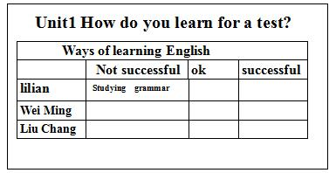
Reflection

